SOUTH WEST FOUNDATION
ENGAGING OUTCOMES
An evaluation report on South West Foundation’s
Community Researcher Programme

Report Produced by South West Foundation with thanks to the evaluator Sarah del Tufo for collecting interviews and data
Contact details South West Foundation
Email: Info@southwestfoundation.org.uk
Tel:01761 471104
Website: www.commumnityresearcher.co.uk
Copyright South West Foundation 2014

CREATING CHANGES

A CASE STUDY BASED EVALUATION OF SOUTH WEST FOUNDATION’S COMMUNITY RESEARCHER PROGAMME

Introduction
South West Foundation is an independent Charitable Foundation. The aim of the Foundation is to invest in communities by:
- Allocating small grants to community groups
- Providing training to individuals in communities so that they can achieve their full potential
- Undertaking research to support the sector
To date the Foundation has raised and allocated just under £5million for the sector mainly distributed in small grants to small groups.
Background
The first Community Researcher course was funded by the Regional Empowerment Partnership in 2007. The initial funding enabled the South West Foundation to work with the Evaluation Trust and a group of residents from the Oldmixon Estate in Weston Super Mare to design the programme. Since then more than 200 people have undertaken the training and more than 4,000 been involved in the research projects.
A number of the training programmes have taken place in coastal towns.Behind the seafronts of a number of coastal towns in the South West lies estates with multiple problems. A number of these estates are in the 10% most deprived communities in the country. The fact that they rest behind relatively affluent seaside towns can make the issue even more difficult for residents. Lack of community engagement and lack of belief that people are listening to their views and voices, together with lack of confidence in their own ability to bring about any change for the better, limits what people are able to achieve both personally and for the community.
The programme has worked with a wide range of communities and neighbourhoods but has also worked with very specific groups such as survivors, carers, older people disabled people, people from minority communities and many more.
This report outlines some of the main outcomes of the Community Researcher initiative as led by the Foundation from 2008-2014. It looks at what has been achieved, sometimes 3-5 years on from when the courses took place, to see what sustainable outcomes the Community Researcher Programme has had.
Methodology
Information for this report was gathered by an independent evaluator through a variety of sources. Information was taken from interviews with participants in the Community Researcher programmes throughout the region. A selection of Community Development Workers and other agency workers who were familiar with the programme were also interviewed and reports on each of the programmes reviewed. Many of the interviews and much of the information gathering took place 3-5 years after the courses, in order to look at the longer term impact of the programme. The report is based on a sample of case studies and looks at what difference the Community Research programme makes, both to the individual and the wider community, particularly where the researchers have received support from local agencies to take forward their dreams.

Summary of Benefits from the Community Researcher Programme 2107-2014
South West Foundation has been running the Community Researcher Programme throughout the South West Region since 2008. Training local community members to undertake their own research projects, gather evidence and present this to those in power in communities to help to bring about change, has proved a powerful tool that has had lasting effects on both communities and individuals. This report has been the first opportunity to revisit those who have benefitted from the programme and to see what lasting outcomes there have been from this programme to date.
Benefits for Individuals:
- The community researcher programme has operated mainly in areas of greatest need. People who have taken part in the Community Researcher programmes have often had a history of their skills and abilities being unrecognised and undervalued. The programme has enabled those individuals to identify their own skills and value; to increase those skills and confidences, to enable them to become major contributors to the well-being of their communities.
- Many of the individuals reported how, having gained the knowledge about how to influence those in power and who to influence, has led to ‘success’ for them, in terms of knowing how to get their views across and their voices heard
- Although it was not an intended outcome of this training, a number of people who had been long term unemployed, did, following the programme become employed in both paid and unpaid roles in their communities.

Benefits for the wider community
- The very tangible outcomes for the wider communities were wide and varied. Community members not only were able to be involved in putting forward their views but often resulted in those views being transferred into action. This action ranged from increased activities and community resources such as play and activities for young people, to the rescuing of land for community use.
- There has been an increase in small community groups being established and new community resources being set up as a result of the research findings. This has included community shops, play resources, new skate park, activities for children, new road crossing, increase in safety, community hubs and groups for young people and older people. This has carried right through to Creating Changes programme in 2014 funded by the health Lottery which resulted in a wide range of community activities being established.
- There has also been reported improvements in relationships between the local community and agencies such as housing and local authorities following the researcher programme taking place. The local communities were able to use evidence gathered through their research to inform their approach to local agencies. Respect and communication between the two has reportedly increased.
- There has been an actual improvement in certain measurements in the communities where the researchers have become active such as lowering of the rate of ASBOs on the Queen Elizabeth Estate in Paignton. It would not be claimed that this is just down to the Community Researchers but also the agencies who have worked with them and supported them to take community action forward.
- There has been an increase in community engagement and involvement in communities where the Community Researchers have been active.

CASE STUDIES

Case study 1

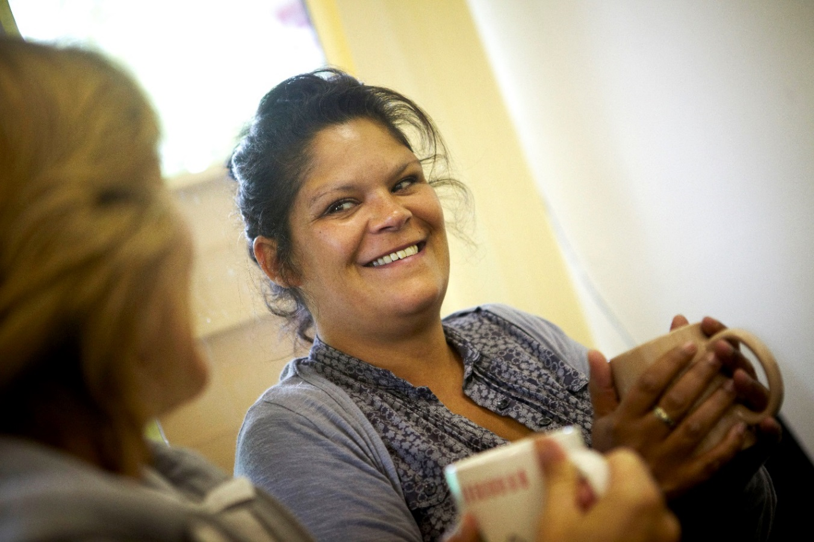
Oldmixon Estate Weston Super Mare

'The Community Researchers really did make things happen... they had a big impact. They go about things quietly but all the things they set out to achieve they managed.’
Community Development Worker: Alliance Homes

The Oldmixon Estate Weston Super Mare

The very first Community Researcher course delivered was with the Oldmixon Parents’ Group. This group of mainly young mums wanted to improve facilities on the Oldmixon Estate behind the sea front in Weston Super Mare. North Somerset and in particular Weston Super Mare has a number of large estates that register within the 10% most deprived wards in the country. The Oldmixon Estate neighbours onto one of these areas, but had found itself attracting far less investment in community facilities than some of its neighbouring estates.
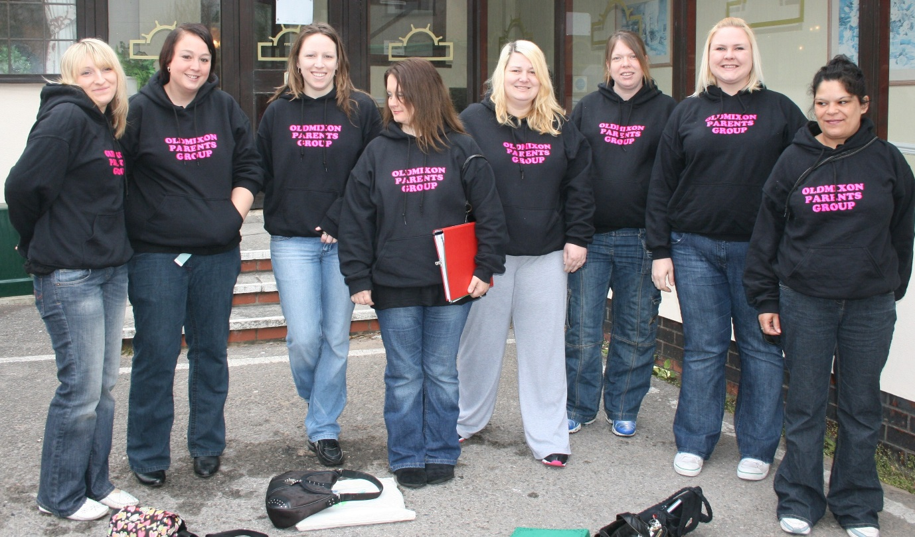
The group wanted to find out what the priorities were for the local community. After undertaking the five week training and designing their research, the group set about undertaking their own research project. Wearing their specially designed sweat shirts, the group interviewed people outside the school, the shops, in their own homes and in the parks. They were looking to discover what the main priority concerns were for the people on the Oldmixon Estate. After interviewing more than 100 people from the local community, their research showed that people had three main concerns:
- There was no information hub or place to meet on the estate
- Mothers in particular were concerned about the lack of a crossing to get to the nearby large supermarket. They found it dangerous when trying to cross the road with small children and buggies.
- A drug rehabilitation hostel had been placed on the estate next door to the park. As much as the community understood the need for a rehabilitation hostel, it was causing difficulties for the children in the park with the dangers of broken glass and needles being left in the park.
The group presented their findings at a seminar to local councillors, housing associations, members of the Empowering Communities’ Partnership, local residents and council staff. As a consequence they were offered the opportunity to take over an empty shop on the estate owned by the housing association. As well as running the training the Foundation organised for them to visit another successful community shop in Swindon on the Parks Estate to help the group to get some ideas for their own shop.

Outcomes
Benefits to the Wider Community
The Oldmixon's Young and Old Unite (YOU) Shop was set up and is now a community hub. It raised over £5,000 by selling secondhand items in its first year. The researchers in the first three years were very busy and dedicated. With the income they organised community activities, children’s clubs, hosted meetings between local wardens and the public - and much more! Some of the original researchers went on to be paid mentors for other groups.

When visited two years after the training, the group had also lobbied and managed to get both the pedestrian crossing in place and the rehabilitation hostel moved to a more suitable location on the estate.

'The Community Researchers really did make things happen... they had a big impact'. They go about things quietly but all the things they set out to achieve they managed
Community Development Worker: Alliance Homes
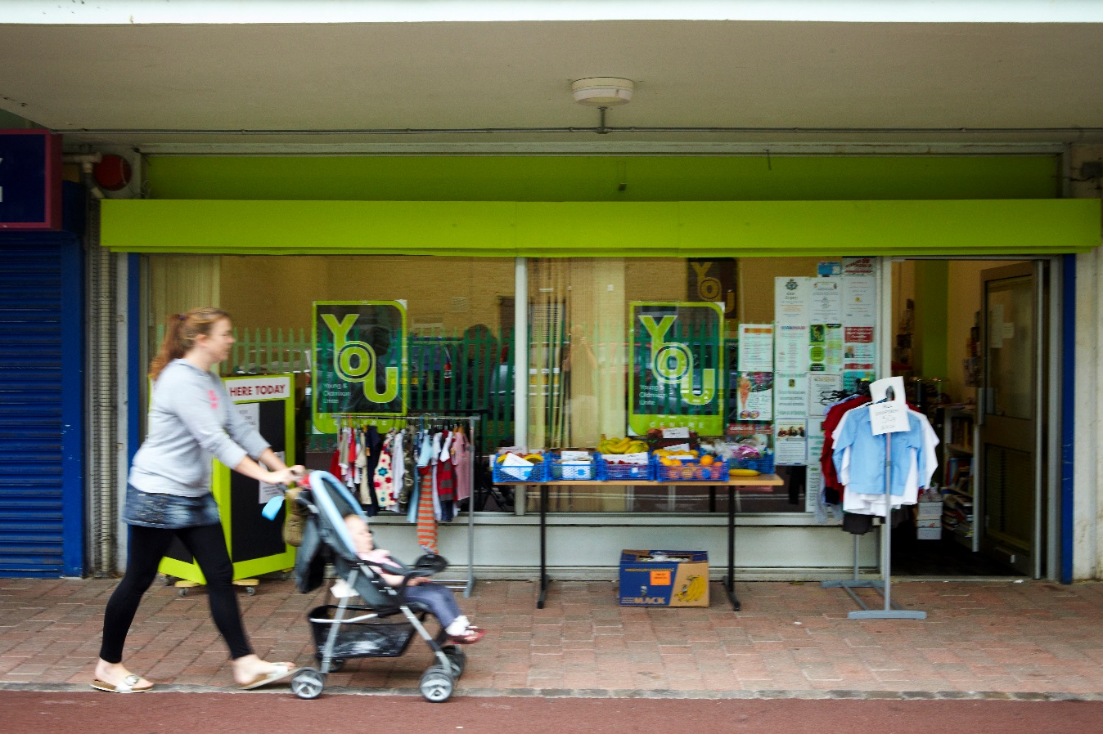
Four years after the training the YOU Shop is still working well as a community shop and venue for the local councillor and other agencies to be available to the community. Oldmixon Parents merged with the group running the shop to become Young and Old Unite (YOU).

Benefits to Individuals
As mentioned, a number of the individuals were able to move onto other roles within the community. A couple became mentor volunteers for other agencies. The former chairperson now volunteers within the local school. Two of the original group moved onto College courses. Trainers reported a vaste increase in confidence in those who took part, based on their new skills and knowledge, particularly around who to influence and how to bring about change. Having the research behind them has also given them the evidence that they need to achieve change.
‘What they did was fantastic… there was a huge confidence increase… big difference for individuals… Many of the researchers are in part time jobs and some are still involved in the YOU Shop which is still going well.
Community Development worker North Somerset Council 2013
As with any group that operates for a number of years the Oldmixon Group has had its challenges. However, as well as undertaking activities to benefit the community, some of the original group members found the confidence to return to education and went on to college or into employment once they had picked up on their own self confidence.
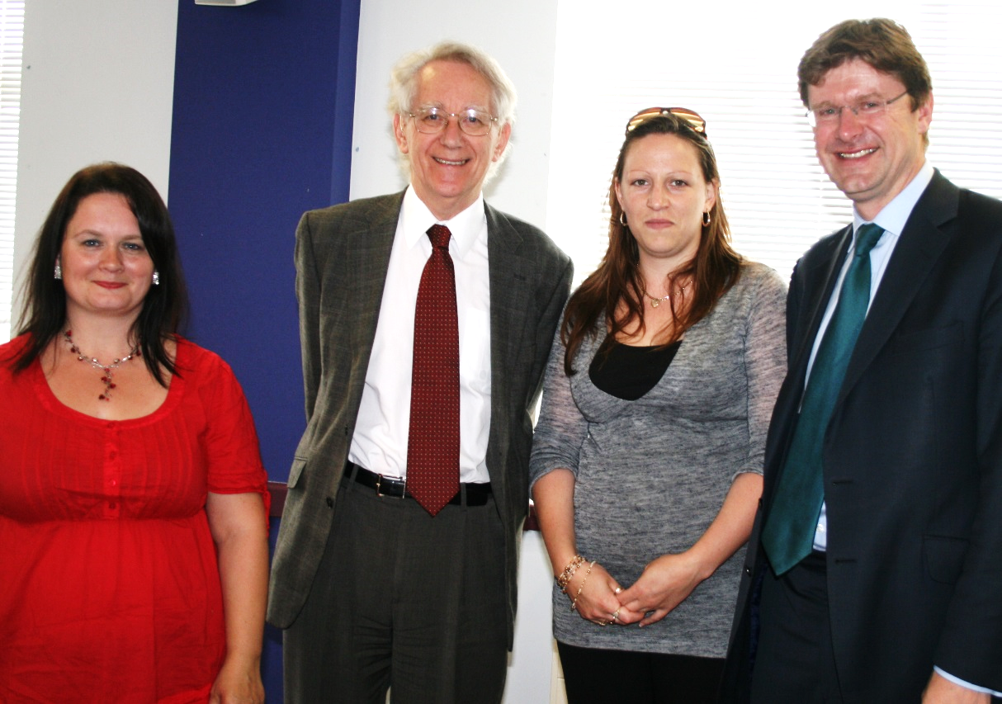
MEETING WITH MPS
In July 2010 Oldmixon Parents Group met with Andrew Stunell, Parliamentary Under-Secretary of State, to discuss Big Society and presented their views on the benefits of the Community Researcher training.

Case Study 2

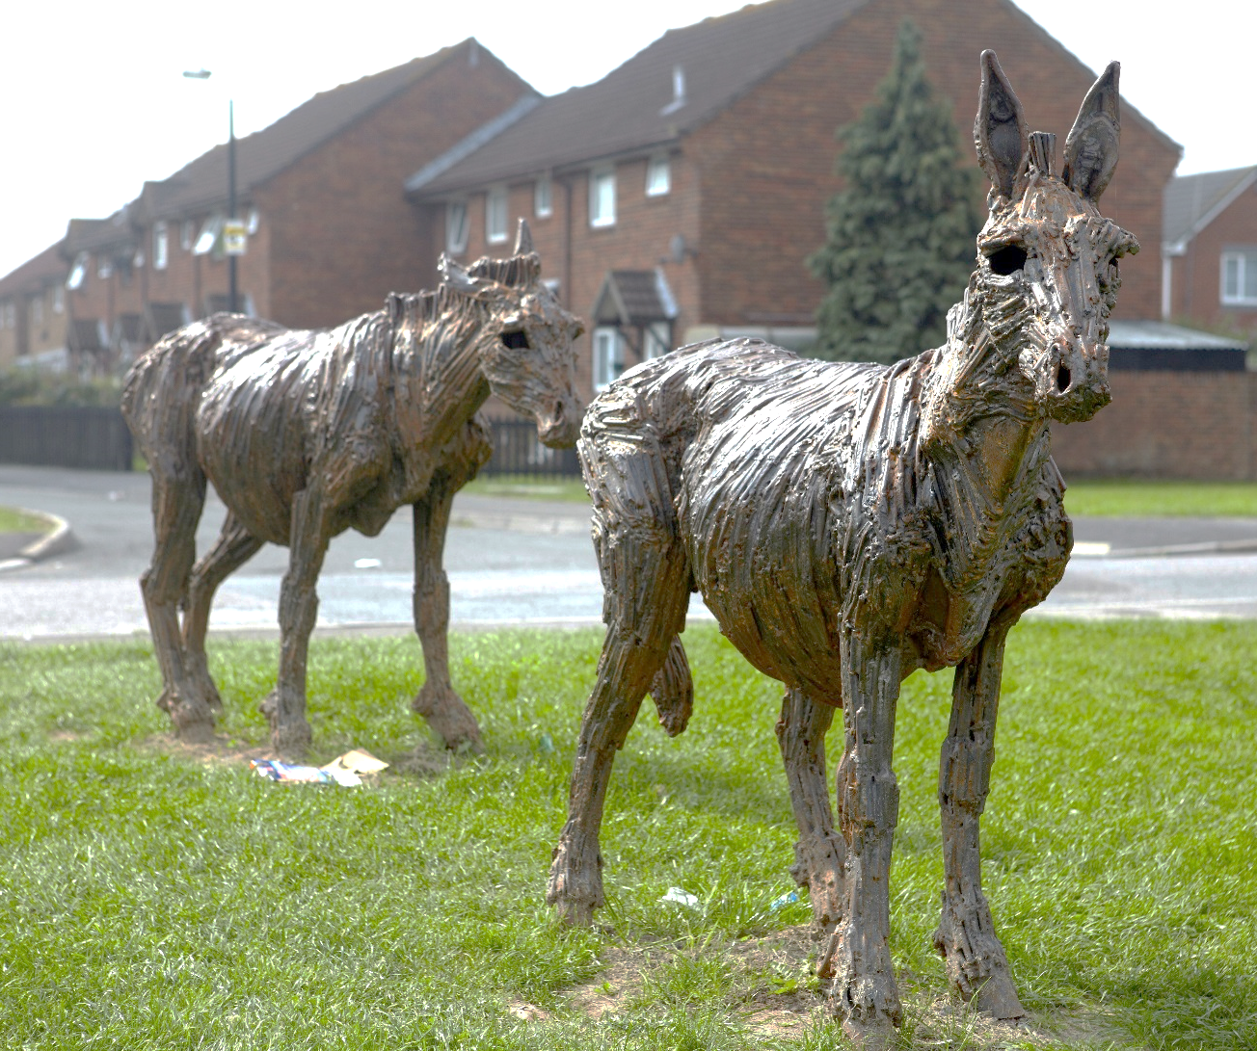
South Ward North Somerset

We decided to do our research on rubbish-rubbish was letting the estate down….
- We have petitioned for extra dog bins in the area
- We have helped to improve waste and recycling collections
- A number of us researchers continued with our research skills and worked with the local library to undertake research into the use of the library in case it was threatened with closure or a diminishing of the services.

Community Researcher South Ward Weston Super Mare

South Ward North Somerset
South Ward is another area behind the seafront in Weston Super Mare, and includes the Bourneville Estate. This estate is amongst the 10% most deprived areas in the Country.The Bournville Estate has had some considerable investment over the years, in recognition of the high levels of deprivation and also has a very active Healthy Living Centre. This is where the Community Researcher training took place.
This group of researchers decided to focus their research on the issue of rubbish on the estate, which was a growing concern. They felt that the rubbish was spoiling attempts to make the estate a nicer place for people to live. It was also adding to the stigma that the area was suffering from. Having designed their questionnaires, they undertook much of their research on the streets to find out what people felt was the main cause of the rubbish nuisance in the area.
Among the main causes identified by the community was the very simple fact that the rubbish bins were in the wrong place for people to use. They were sited off the main pathways and areas where people congregated.
There were also issues with people leaving larger items of rubbish and furniture on the streets. There were noticed telling people that ‘Fly Tipping’ was prohibited. However, most of the community members when asked about fly tipping, were not sure at all what ‘fly tipping’ was.
Outcomes for the Wider Community
Through the research, the group made good links with Council’s recycling project. They found that the agencies such as the Council and the housing associations were very helpful and appreciated the fact that they were doing the research. Communication between the community members and the agencies improved through the personal contact and the fact that the community found that the agencies would listen to them. Good communication was established with the recycling services. For example the council brought a mini recycling centre to the community Funday to help with clearing up.
The findings of the Community Researcher programme became part of a long term process to improve rubbish issues which the Bournville area for Residents Association is still working on.... some of the Community Researcher group stayed involved in the rubbish issue through the Residents Association. Having started their involvement and built their confidence, a number of the researchers got involved in other community projects such as a drama project and made a film on the estate.
Those who have stayed involved in the residents association meet regularly improving their local neighbourhood. The association is run by residents, for residents and the group covers the Bournville, Coronation, Oldmixon and Potteries.
Things we have achieved so far:
- We have petitioned for extra dog bins in the area
- We have helped to improve waste and recycling collections
- A number of us researchers continued with our research skills and worked with the local library to undertake research into the use of the library in case it was threatened with closure or a diminishing of the services.

A Community Researcher from South Ward

The area is now a Community First Area and some of the researchers are involved in the panel with this including Sam who was a very active member of the Community Researcher, group and features in the film which looks at Community Researcher outcomes. Sam is on the Community First panel and continued to use his research skills.
Benefits to individuals
The participants saw the benefits of being involved in learning activities with a group of people... you cannot predict how open to change people are; the course just came at the right time and fitted people’s own life goals-

Community Development Worker North Somerset Council 2013

Case Study Three

Queen Elizabeth Drive Paignton
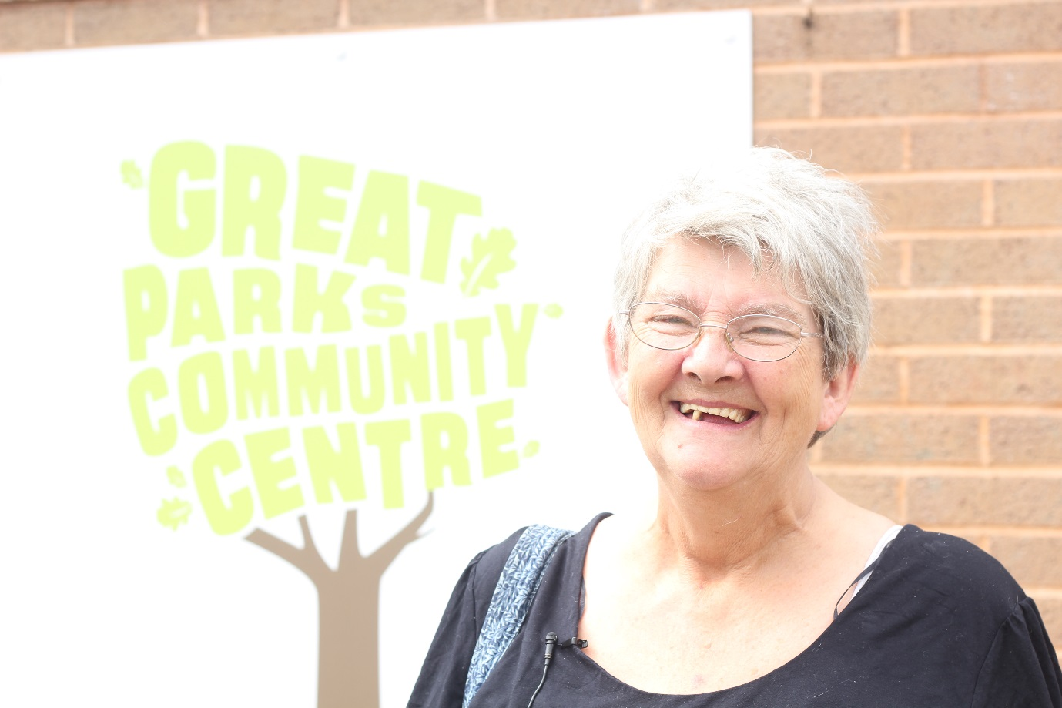

The course gave me a great deal of confidence I met a lot of good friends- lasting friendships through the first project. We have come together with Foxhole Community Centre. We know each other now and help each other ….it made me do things I had never done before…like the presentation.. It gave me confidence for my presentation- now I have done many presentations since and I love it….

Kath Sowden Community Researcher Queen Elizabeth Drive Paignton
(Now Chair of Great Parks Community Centre)

Queen Elizabeth Drive, Paignton

The Foundation was able to run a number of Community Researcher courses in Torbay with an excellent partnership with Sanctuary Housing. Kath Sowden from Queen Elizabeth Drive in Paignton took part in one of the first Community Researcher Courses in the area. Kath then took part in the course a second time two years later. Now in 2014 Kath is very involved, and has been very involved for a number of years in getting projects running through her local Community Centre in Great Parks. The projects have been of great benefit to the local community.
The course gave me a great deal of confidence I met a lot of good friends- lasting friendships through the first project .We have come together with Foxhole Community Centre. We know each other now and help each other ….it made me do things I had never done before…like the presentation It gave me confidence for my presentation- now I have done many presentations since and I love it….
The Community Centre, with Kath’s help and the help of local agencies such as Sanctuary Housing, now has a whole host of activities, particularly for young people and the community and they have been able to measure the effect that these initiatives have had. Kath has also been able to engage significant numbers of people from the local community in activities at the centre. Outcomes for Individuals
Kath and a number of her fellow researchers in Paignton have continued their engagement with their local community. People on the estate know her as ‘Nanna Kath’. As chair of the local community centre and with support from agencies Kath herself has become a community leader.
It is hard work but I love it…I love it the community needs it so we have to keep going the kids need it….the ASBO rate has gone down by 50% on the estate. The police have written a report about it it’s brilliant….I will stay involved they will have to take me out of here in a wooden box.

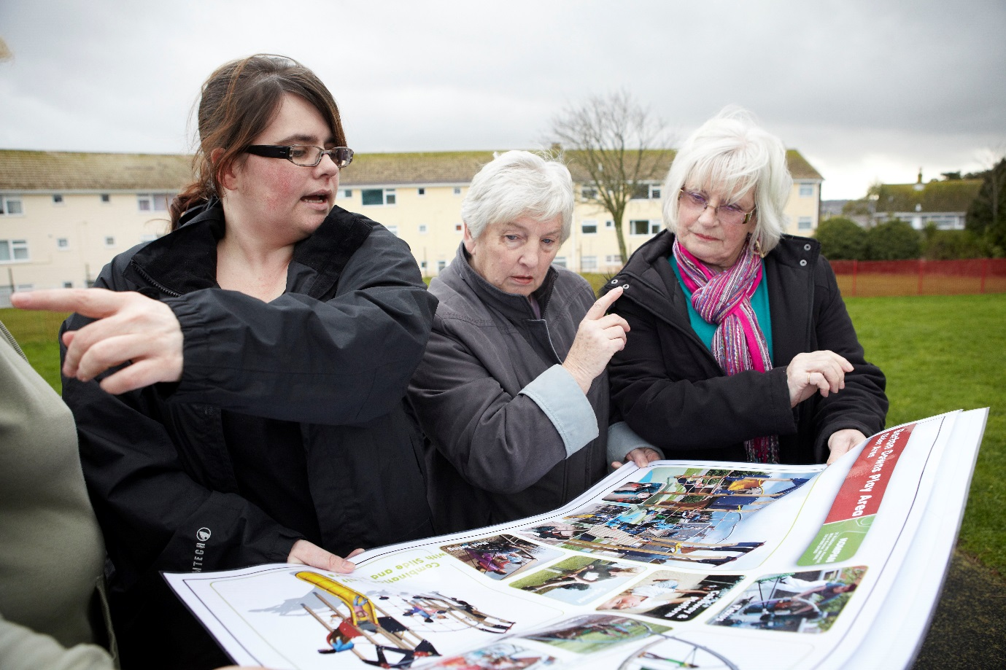
Case Study 4: Litchfield and Pendennis Estates

I took part in the Community Researcher Training this time last year. The green space was being sold off for development. We had spent two years trying to stop this going through. We wanted it for a play park for the children. This is what the community wanted.
Without the Community Researcher Training I would not have known where to go. We were able to collect all our researcher evidence about what the community wanted. Just before Christmas we had the best Christmas present ever, and were told that not only did we have the Playbuilder money but also £50,000 from the council. Work is due to start in two weeks.
Community Researcher and member of Litchfield Residents’ Association

Litchfield Estate Torquay

Another Torquay based Community Researcher course took place at the Windmill Centre on the Pendennis Estate. People joined together for the course from both Pendennis and Litchfield Estates in Torquay. The two areas traditionally had not worked together.
One of the researchers was working with a residents’ group on the Litchfield Estate who had been trying to save a green space near their houses for a children’s play park. For 15 years there had just been one swing on the play park and people wanted more for their children than they had been able to have themselves. Through face to face interviews the researchers gathered the evidence about what people wanted on the green space, as part of their effort to retain at least some of the land as a play facility.
I took part in the Community Researcher Training this time last year. The green space was being sold off for development. We had spent two years trying to stop this going through we wanted it for playpark for the children. This is what the community wanted. We failed to get match funding and could not access the lottery grant.
Without the Community Researcher training I would not have known where to go. We were able to collect all our researcher evidence about what the community wanted. Just before Christmas we had the best Christmas present ever, and were told that not only did we have the Playbuilder money but also £50,000 from the council. Work is due to start in two weeks.
Litchfield Residents’ Association

Pendennis Estate Torquay (Windmill Action Group)
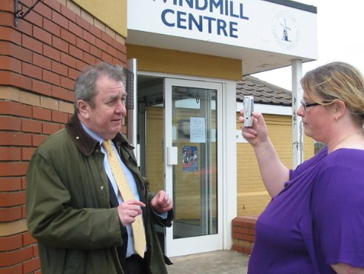

Two residents from the Pendennis Estate who took part in the same Community Researcher Programme, wanted to explore what young people and children on their estate wanted. Many rarely left the estate.
The children came up with brilliant ideas. The council were so pleased with our work that they gave us £1,000 to take the children on outings. We organised a fossil hunt outing to Lyme Regis and an outing to Creally at Halloween. … also I could talk to people that I don’t usually talk to…and made a video with the local MP…We are now trying to raise £150,000 to upgrade the local skate park… For this we did questionnaires again to see what the community wanted for this park. If it had not been for the Foundation course we would not have known where to start. They helped us to find out what the community wanted.
The group did an amazing job and raised a total of £150,000 for the skate park, some through the Lottery People’s Millions. Unfortunately the developer let the group down and the group went through a very difficult time. However 4 years later the project is still running and new funds have been accessed to move the skateboard park forward. The two residents went on to organise other activities on the estate and assist the housing association to put on events and activities including a tea dance and street party.

Case Study 5

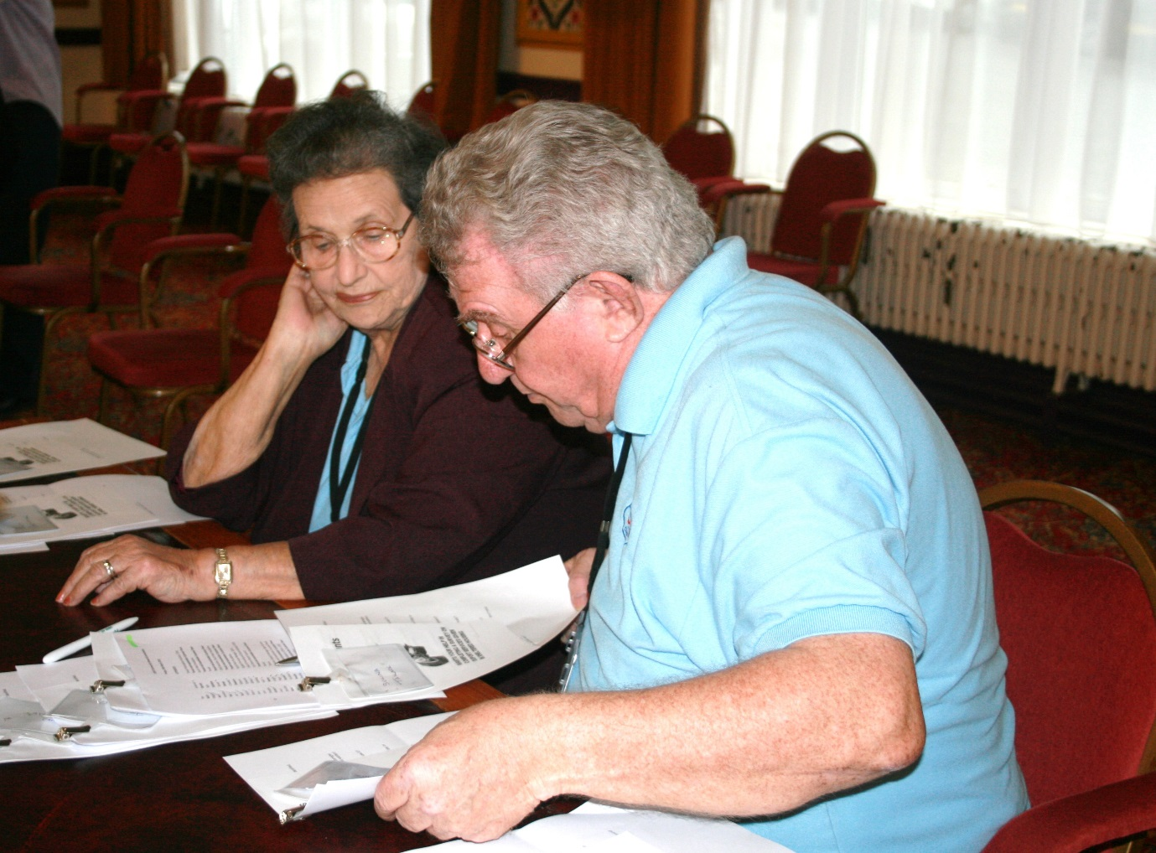
Older People as Researchers

The Foundation had reports from East Devon Council that the older residents were a great asset. The residents carried on using their research skills. The Foundation was invited back two years later to hear the researchers report back on their most recent research. This research had involved gathering the views of over 300 local residents. The researchers were seeking their views on the council newsletter. This research assisted the council to ensure that whatever they spent on the newsletter in the future was on content and activities that the residents appreciated and items that they had an interest in reading.
Source: Foundation Community Researcher report 2013

Older People in Chippenham  The Foundation has run as number of training courses with older people. In Chippenham, for example a number of older people wanted to undertake research looking at issues around mobility scooters. The researchers looked at where mobility scooter owners kept their mobility scooters when they were not in use. This can be quite a challenge for residents in houses that are not designed to accommodate such large items. They discovered that there were many legal and safety issues involved for residents because there was no dedicated space for mobility scooters to be stored. Residents were having to make their own, often unsafe ways of storing and charging their scooters. Once the researchers had gathered the evidence, they were able to present this to the housing association who had not realised the extent of the problem.  Outcome: We heard two years later that the housing association, as a result of the research, went on to build a mobility scooter shelter in their properties where most disabled and older people live.  Older People in East Devon  A group of residents in Exmouth wanted to research the issue of wardens being removed from warden controlled properties because they felt sure that older people were suffering from the withdrawal of wardens. Having undertaken a huge number of interviews, over 150, to their surprise they found that people actually quite liked the new system, found it very effective.  They presented these findings to the Council who had also expected a different outcome from the research. They had feared that older people would be missing the wardens but budgets had demanded that the wardens be replaced by remote call systems. To find that their residents were actually experiencing a good and satisfactory service via the new system was a great relief to the Council. It was arranged that the researchers should visit a call system to see how it worked. The Council found found it extremely helpful to have access to residents with research skills when it came to future planning on a number of topics  Outcomes  The Foundation had reports from East Devon Council that the older residents were a great asset. The residents carried on using their research skills. The Foundation was invited back two years later to hear the researchers report back on their most recent research. This had involved over 300 local residents. The researchers were seeking their views on the council newsletter. This research assisted the council to ensure that whatever they spent on the newsletter in the future was on content and activities that the residents appreciated and items that they used. It was discovered that significant numbers of residents actually read the newsletter. In some ways the research re-affirmed that the newsletter was of benefit and should remain in place. Now 4 years later the Foundation has been asked back by the council to training a new group of residents with our excellent training programme.  Case Study 6:Young People as researchers |  | - this was such a disparate group
A group of young mothers in North Somerset, some of whom also had serious mental health issues, undertook a programme that was tailor made for them. Having bad experiences from school, and feeling almost that their lives were over, it was initially difficult to engage this group of young parents. The trainer used a range of art based activities to engage the young people in giving their views of what an ideal community would be like. When asked to design their own ideal community, they designed communities that were full of activities and opportunities for their children, nothing for themselves. Showing how their total focus and desire was to ensure a better life form their children.  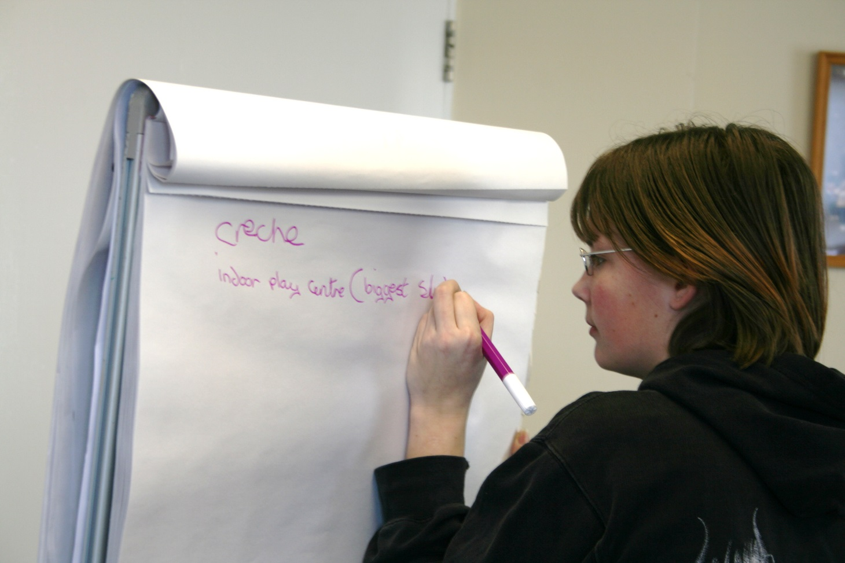  The Foundation then paid for the young people to take their children to the local museum. It turned out that none of them had ever been to the museum before although it was only a matter of minutes away from where some of them lived. They were nervous about going in to the muse. They felt that their children might misbehave, they would be seen as bad parents and the children taken away. Such was their lack of belief in themselves. Once at the museum the young mothers worked with their children to research how well the museum addressed the needs of parents and young children. They then presented their findings informally to the manager of the museum who was pleased to chare his time and listen to them. This was the first item that these young people had engaged with any form of community type project. |  | - Milton this was group of young single parents who also had additional challenges. Not known to Miriam as they were based outside of Bristol. They went and undertook research looking at how the facilities could be improved for mums with young children and presented this to the head of the museum. We lost contact because the support worker was moved on and the vicar also left. I think the group folded.

Case Study 7

Working with Minority Groups
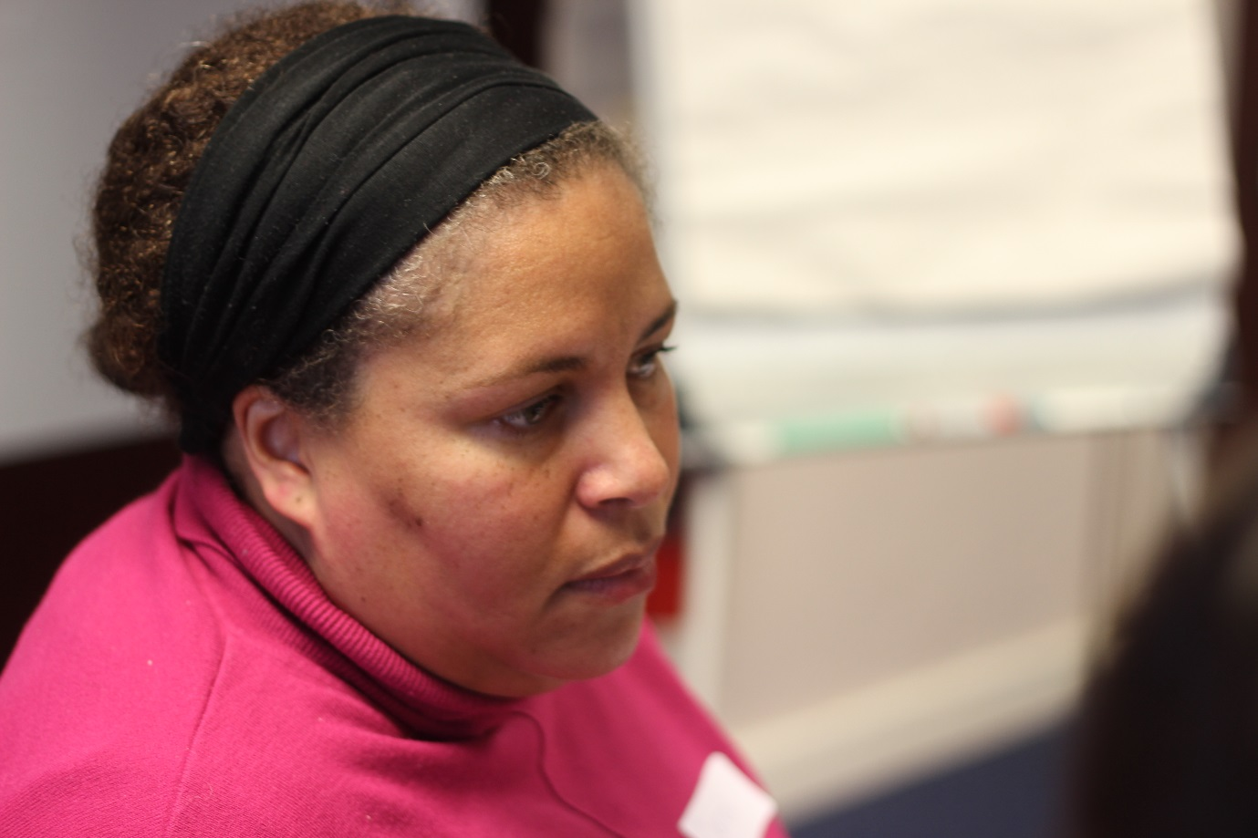

After the faith audit questionnaire had been sent out, the researchers conducted phone interviews, made direct contact in order to gather the information. This direct contact enabled a spectacularly successful return rate of questionnaires, 118 faith groups, a response rate of over 60%, compared with an acceptable, but lower, return rate of around 33% from earlier audits conducted in other local authority areas….it is one of the best pieces of research undertaken.

Local Authority Development worker

North Somerset Black and Minority Ethnic Network and North Somerset Multicultural Friendship Association.

Around 26% of the people who took part in the Community Researcher training overall identified themselves as coming from minority ethnic groups. In Central Ward in North Somerset a number of the researchers were members of the North Somerset Forum and the Multicultural Friendship Association. As a group they undertook research into a number of different topics. The group were multi skilled and the research they undertook was often quite intensive. One of the research projects looked at research into activities for primary school children. The findings mainly focussed on outdoor play and the need for more sports and arts clubs. This research was fed back to the school.

Outcomes for Individuals

The main outcome from this research was the building of confidence among the group themselves who also showed what incredible skills they had. There have been a number of pieces of public research that have looked at the issue of how well qualified and skilled women from minority groups are, but that often they are unable to use their skills in the UK because their qualifications are from other countries. The research projects gave the women the chance to demonstrate and reflect on those skills. The researchers have continued to be involved in a number of pieces of research that have led to outcomes and new projects in the local community. Some went on to obtain employment, a number stayed as volunteers within the community groups. Others carried on using their research skills.

Outcomes for the Wider Community

The researchers were later asked by North Somerset Council to undertake a piece of research with Faithnet, a regional network of faith groups. The research project involved looking at the various faith groups that operate in North Somerset and what their contribution was to the community.

After the faith audit questionnaire had been sent out the researchers conducted phone interviews, made direct contact in order to gather the information. This direct contact enabled a spectacularly successful return rate of questionnaires, 118 faith groups, a response rate of over 60%, compared with an acceptable, but lower, return rate of around 33% from earlier audits conducted in other local authority areas….it is one of the best pieces of research undertaken.

Local Authority Development worker

A development worker with the Race Equality Council said;

After the faith audit some 2 years previously, the group were involved as part of the Fair Share programme with Quartet in talking to local people in Central Ward, Weston where people experienced deprivation and isolation. It covered areas like how much did people go out; did they have family locally or friends? were they registered with GPs? what activities/ info they needed?

Early in 2011 a subgroup of the Local Panel, with the support of the Evaluation & Sustainability Officer, undertook a review of community needs in Central Ward to identify sections of the community who had not benefited from previous community development activity.

The researchers from minority communities have been a great asset to the local community and the local authority and are now well skilled in undertaking research. They no longer have the Race Equality Council for support in North Somerset or to support the local community and have been undertaking a great deal of this role themselves through the Black and Minority Network.

Case Study 8

Service Users as Community Evaluators of Services

SEEDS
(Survivors Empowering and Educating Domestic Abuse Services)

The Foundation first became involved with SEEDS groups in South Somerset in 2003. SEEDS is a model of working with survivors of Domestic Abuse as researchers. There are now a number of SEEDS groups throughout the region. The aim of the SEEDS group is to empower survivors by enabling them to have a voice and say in how services are developed for survivors.
The North Somerset SEEDS group was quite new when the Foundation started to train them in how to undertake research. The plan was for women who were survivors of Domestic Abuse in North Somerset, to pick up research skills so that they could interview other survivors about their experiences of the various agencies. Their research would later be presented to the services so that they would have the evidence for how to develop future services. The group in North Somerset chose for their research to look at women’s experiences in two short stay Nova Scarman hostels in Bristol. The research was a valuable piece of research in its own right, as it showed a remarkable difference between the women’s experiences in each hostel. After the course the group then went on to undertake a major piece of research, looking at service users views of the services. They held a major conference and have presented their findings to the agencies.

Case Study Eight

Carers as Community Evaluators
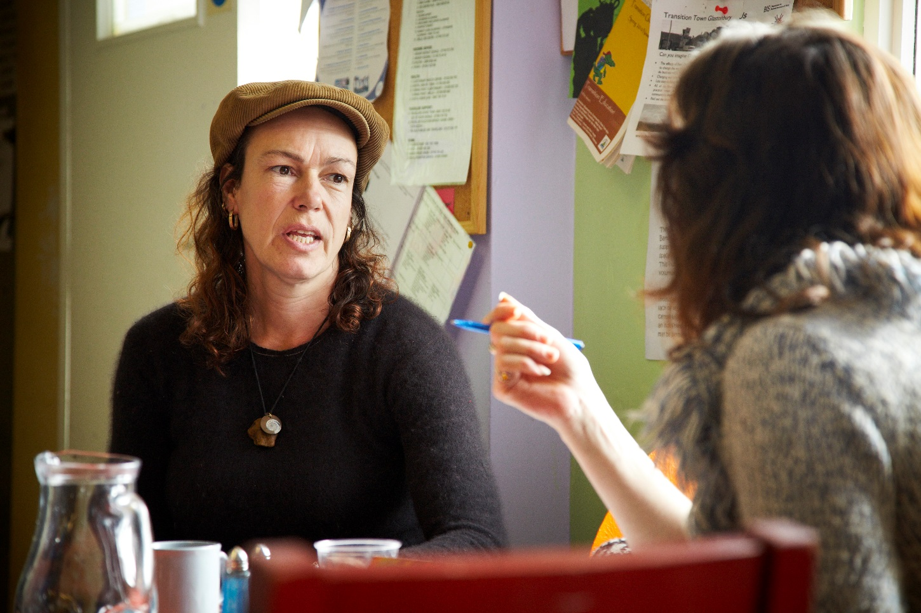

The course led to a huge development of confidence; they did lots presentations; they increased self-esteem…From this training an established group of carer evaluators have been working within the health service for over 4 years now. ..For example they have been involved in residential homes, reviewing the carer’s register and the online carers forum.

Lead Officer Integrated Carers Services at Torbay NHS

Carers as Evaluators
Funded by Torbay Health Authority and on the back of the Community Researcher Programme on Pendennis Estate the trainers were asked to deliver a programme to carers through the Health Authority. The aim of this training was to enable carers to undertake evaluations of existing services in the areas for carers. The approach used was very similar to that of training the Community Researchers. There was a lot of crossover.

The Course led
To a huge development of confidence; they did lots presentations; they increased self-esteem. Some went for paid work but most are still involved. They continue to meet as a group every second Sunday. The Group has become a close and an informal support group.

From this training an established group of carer evaluators have been working within the health service for over 4 years now. The carers are mainly used alongside other independent researchers..and paid for their input .For example they have been involved in residential homes, reviewing the carer’s register and the online carers’ forum. The group do 3 evaluations each year, built into work and covering full programme….That there is no other initiative like it in region and I don’t know nationally. ..There is real evidence that carers feel valued- they have the confidence to speak to another carer. Impressive group- it has enhanced their CVs....The project has senior manager recognition. The learning from the evaluations has been implemented- used as part of the evaluation process...

Community Evaluations

A spring off from the Community Researchers has been the community evaluations. The two models are interlinked with different focuses. However, a number of the outcomes have been very similar. A major community evaluation was undertaken with the Hele’s Angels Project in Torbay. Hele’s Angels is a community organisation that developed from a neighbourhood partnership. They wanted to know what the local community thought of the work that had been undertaken by Hele’s Angels partnership, whether people knew about what was on offer and had they, at the end of the day, been able to make any difference to the community.
A number of volunteers from the organisation trained in evaluation and research and undertook a community evaluation by talking to people outside shops, outside takeaways and in other community facilities.
The evaluation showed a very positive view that the community had of the difference that Hele’s Angles was making by improving the local environment. The evaluation was great help to Hele’s Angels when looking at its future and the Foundation went on to employ one of the researchers in later project. One of the Community Evaluators went on to work with the Foundation a future research project and two returned to assist with the later Creating Changes Health Lottery funded project.

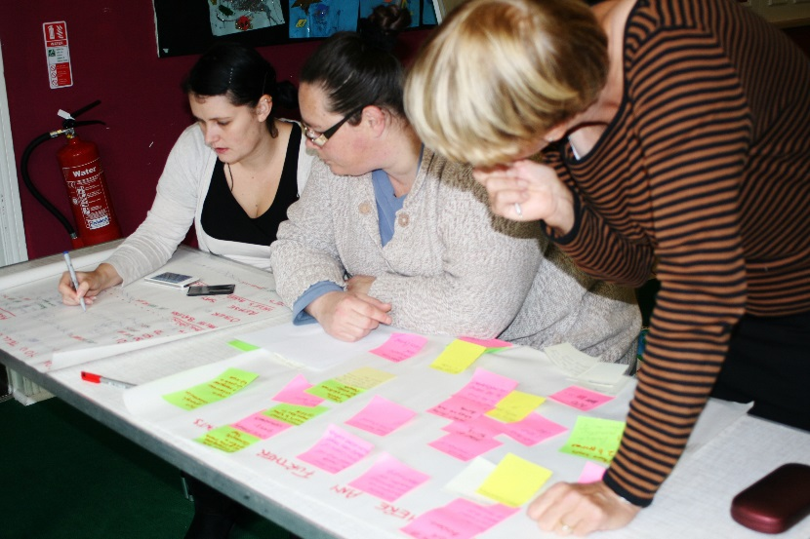

Case Study Nine

Moving on: Creating Changes
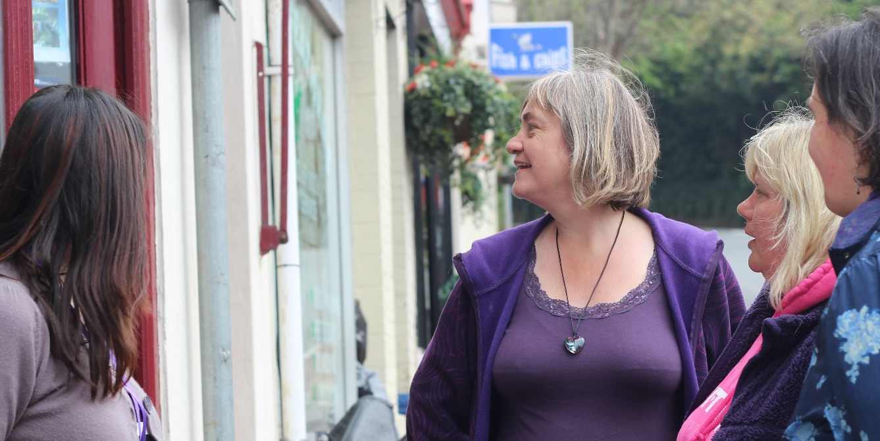

We had done our research and we now know from the research what people want. We are trying to work on setting up somewhere where people can meet. We want to do something for older people and a mother and toddler group….we know what it is like and the effects of isolation from our own experience so we wanted to give something back to the community.

Community Researcher Chelston Torbay

The Creating Changes Programme
More recently the Foundation has been funded by the Health Lottery to provide a longer term programme 18 month project in the 10% most deprived areas of Torquay. Creating Changes focussed not just on people undertaking research to identify priority community needs, but also looking at and assisting with providing solutions.
Training was undertaken in Ellacombe, Chelston, Pendennis, Hele and Barton with a core group of 20 women who wanted to make a difference to their communities. From the Creating Changes Project the participants, as well as picking up on their own confidence, skills and knowledge about their local areas, led on setting up a number of new projects and activities in the area. There is a full report available on the Creating Changes Project in Torbay. Below is just a selection of the community outcomes so far form the project.
Chelston
A group of women in Chelston, after doing their research have started looking how to address the issues raised through the research.
One group has set up a youth club using their connections
I knew the church from my own childhood and asked them if we could use their hall. I managed to persuade the council to give us a grant. It was hard work and I had to go along and do a presentation. We now have one of the most popular youth clubs around.
The group also set about working with other partners on a community hub

We had done our research and we now know from the research what people want. We are trying to work on setting up somewhere where people can meet. We want to do something for older people and a mother and toddler group….we know what it is like and the effects of isolation from our experiences

The Friendly Fundraisers-Acorn Centre
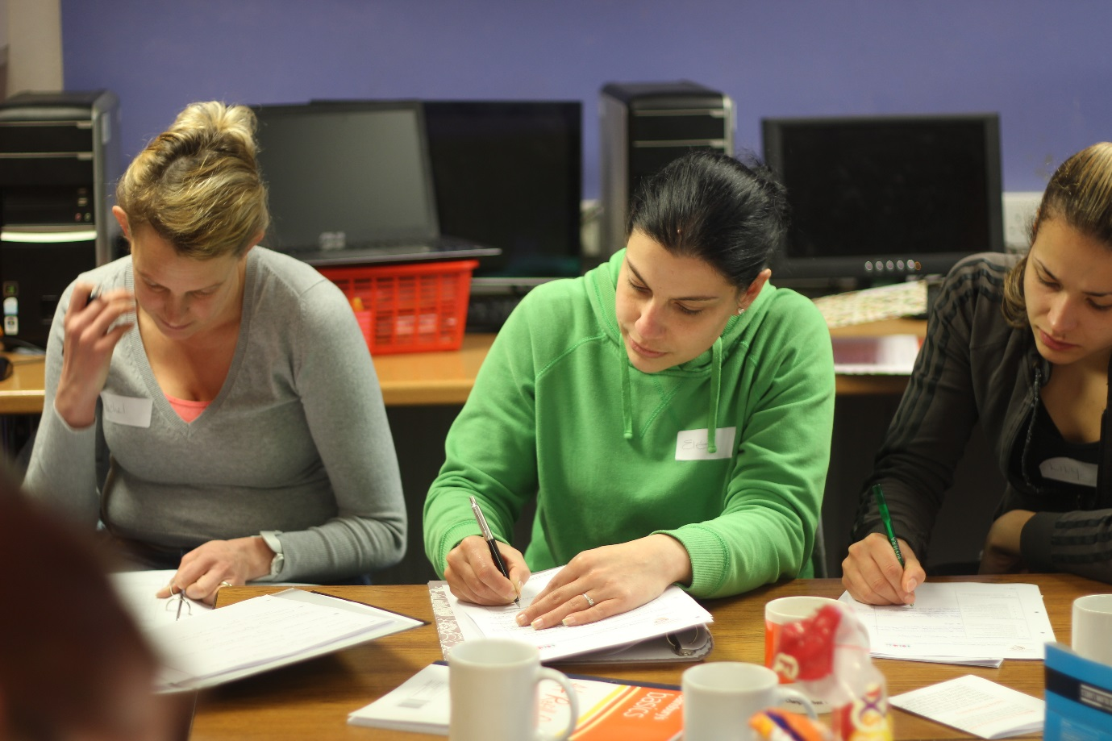

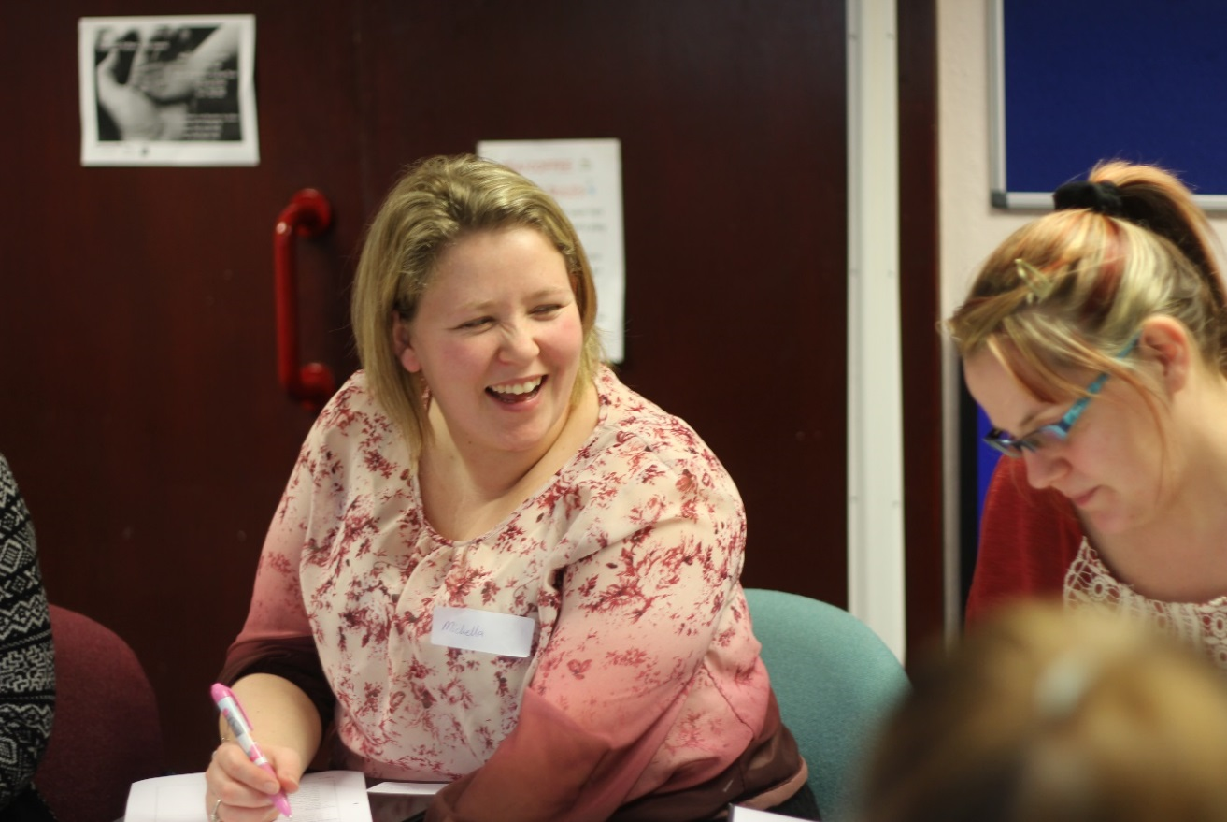

The Acorn Centre is a community and sports facility that rests between Hele and Barton in two of the most deprived areas of Torbay. The Acorn Centre is considered a gem by the local community and used for a wide array of activities from Children’s events and activities to community lunches for older and isolated people.
I have wanted a group like this to help the Centre for years and now we have them. I don’t know how much money they will make but they help with community lunches and community events and are just great.
Manager of the Acorn Centre

Appendices

Training Courses and Research undertaken include:

- North Somerset; With SEEDS Domestic Violence Survivors group looking at women’s experiences in two short stay hostels in Bristol
- Chippenham: Wiltshire: Great Western Researchers with Westlea Housing and Guinness Trust looking at community needs.
- Exeter: Looking at estates in Redruth and Cambourne with Guinness Hermitage looking at the community’s views on facilities
- Paignton: Researching the experience of residents on estates in Exmouth and Paignton with Sanctuary Housing Association
- Wiltshire. Sarcen Housing: A number of different groups from carers to people recovering from mental health issues looking at service provision for their client groups.
- Torquay: resident’s views on play facilities on the Litchfield Estate and with Windmill Action Group looking at facilities on the Pendennis Estate for younger people.
- Milton: North Somerset: young mothers looking at shopping facilities in Worle and the facilities for young children in the local Museum
- Central Ward: North Somerset: looking at school children’s views on activities available to them and what other community activities they would like to see in the area.
- Oldmixon: North Somerset: residents views on facilities on the Oldmixon Estate and what their priorities were for additional activities.
- South Ward: North Somerset: Views on play facilities and how rubbish on the estates could be better addressed
- Wiltshire; Westlea Housing : a look at issues concerning mobility scooters for disabled people
- SURF: people recovering for drug and alcohol problems looking at the experiences of service users in Weston Super Mare with North Somerset Council.
- Horfield Community Association: with Bristol Community Housing Foundation looking at the use and potential use of the community centre( they joined with Surf)
- Gloucester: on the Matson/Podsmead Estate working with community researchers to look at what new activities people would like to see in their area with Gloucester Council and GL11 Communities
- East Devon: Older people looking at the views of people affected by the removal of onsite wardens and being replaced with on call systems
- Cornwall: working with SEEDS survivors of domestic Abuse in Cornwall to look at survivors experiences of refuges in the County
- Foxhole in Paignton: Looking at community services for older people in QED and Foxhole. Also research into people’s experiences of living in the Watcombe area of Torbay and play facilities for the under fives in Preston.
- Research into Ellacombe in Torquay and the need for a community facility in the park
- Research into the needs of the community in the Chelston area of Torquay
- Barne Barton in Plymouth. Residents looking at the needs of the community with support from Zebra and Sovereign Housing

